Supplementary Table 1 Information on the 11 Odorants and the Parameters of Olfactometer Set up for the 11 Odorants and the Icewine
OlfactometerModule ª | Volume ^{b} (mL) | Odorants | Flow (mL/min) ^{c} |  |  | Solution ^{d} (wt. %) | Solvent | Odor description | CAS no. | Involved block ^{e}
OlfactometerModule ª | Volume ^{b} (mL) | Odorants | low | medium | high
Control L/R | 40 | ultra-pure water | 1500
Dilution L/R | 40 | ultra-pure water | Odorants + Dilution = 1500
L1 | 10 | 3-methyl-1-butanol | 30 | 50 | 70 | 8.89 | propylene glycol | alcohol | 123-51-3 | A; B; C; D
L2 | 10 | ethyl 2-methyl butanoate | 35 | 48 | 55 | 0.798 | propylene glycol | tropical fruit | 7452-79-1 | A; B; C; D; Warm up
L3 | 5 | β-damascenone | 40 | 55 | 65 | 0.677 | propylene glycol | honey | 23696-85-7 | A; B; C; D
L4 | 5 | 3-methylbutanoic acid | 100 | 130 | 180 | 0.223 | ultra-pure water | cheese | 503-74-2 | A; B; D
L5 | 5 | guaiacol | 40 | 60 | 80 | 0.899 | propylene glycol | smoke | 90-05-1 | A; B; C; D; Warm up
L6 | 5 | furaneol | 30 | 60 | 80 | 0.336 | propylene glycol | caramel | 3658-77-3 | A; B; C; D
R1 | 5 | 1-hexanol | 35 | 55 | 75 | pure |  | green | 111-27-3 | A; C; D;  Warm up
R2 | 10 | phenylethyl alcohol | 40 | 90 | 160 | pure |  | rose | 60-12-8 | A; C; D
R3 | 5 | γ-decalactone | 30 | 80 | 150 | pure |  | apricot | 706-14-9 | A; C; D
R4 | 5 | methional | 35 | 50 | 70 | 0.0786 | propylene glycol | cooked potato | 3268-49-3 | A; C; D
R5 | 5 | 1-octen-3-one | 15 | 35 | 50 | 0.0757 | propylene glycol | mushroom | 4312-99-6 | A; C; D
R6 | 15 | icewine | 100 |  |  | original |  |  |  | A; B;  Warm up  Control
ª Flow module controlled by olfactometer, L represents the left channel and R represents the right channel, but they were connected to provide only one outlet at the olfactory port; ^{b} The volume of odor solution injected in each olfactometer chamber; ^{c} The air flow went through the odorants in each olfactometer chamber under different flows to produce the expected Low, Medium and High intensity level; ^{d} Solution of odorant that was used in the formal experiment delivered by Olfactometer; ^{e} The label of 4 experiment blocks listed in Supplementary Table 2.
Supplementary Table 2 Information on Odor Stimuli in the Different Blocks
Session and Blocks | Involved odorants | Experimental design description | Combination | Number of stimuli
Training  (52) | All the 11 odorants in Supplementary Table 1 and real icewine at medium intensity | To train subject to identify 11 odorants and to be familiar with different odor descriptors; determining the perceived intensity of different odorants’ aroma attributes at low and high concentrations. | The 11 odorants at medium intensity (mark) | 11
Training  (52) |  |  | The 11 odorants at medium intensity (feedback) | 11
Training  (52) |  |  | Real icewine odor at medium intensity (2); The 11 odorants at low and high intensity | 24
Training  (52) |  |  | Real icewine + 6 single odorants at medium intensity | 6
Warm up | Ethyl 2-methyl butanoate, guaiacol, 1-hexanol and real icewine at medium intensity | To activate subjects’ performance | One single odorants (3); real icewine (3)  One single odorant and one icewine for each session | 6
Control (3) | Real icewine at medium intensity | control; repeatability and stability assessment | real icewine (3), and one for each session | 3
A (33) | All the 11 odorants in Supplementary Table 1 at low, medium and high intensity | Exploring the influence of the intensity of key odorants | Real icewine + 11 odorants at 3 intensity levels | 33
B (57) | 3-methyl-1-butanol (vector L)  ethyl 2-methyl butanoate (vector E)  β-damascenone (vector N)  3-methylbutanoic acid (vector A)  guaiacol (vector M)  furaneol (vector F) | Exploring the influence of different combinations, different numbers of Ferreira's aroma vectors (V. Ferreira et al., 2016) | Real icewine + two-odorant combinations | 15
B (57) |  |  | Real icewine + three-odorant combinations | 20
B (57) |  |  | Real icewine + four-odorant combinations | 15
B (57) |  |  | Real icewine + five-odorant combinations | 6
B (57) |  |  | Real icewine + six-odorant combination | 1
C (11) | all the 11 odorants in Supplementary Table 1 except for 3-methylbutanoic acid | Omission test (data not shown) | A mixture of 10 odorants | 1
C (11) |  | Omission test (data not shown) | A mixture of 9 odorants (1 odor omission) | 10
D (55) | All the 11 odorants in Supplementary Table 1 | Interaction of binary odor mixtures of key odorants in icewine (data not shown) | All binary combinations | 55

Supplementary Table 3 Panel Performance in Evaluating the Same and Different Icewine Odor Samples
Aroma attributes | Same Icewine Odor Sample |  |  | Different Icewine Odor Mixture Samples
Aroma attributes | Sample | Sample × subject | Sample × session | Sample | Sample × subject | Sample × session
alcohol | 0.989 | 0.520 | 0.531 | 0.005 | 0.288 | 0.092
apricot | 0.823 | 0.360 | 0.161 | 0.000 | 0.103 | 0.538
caramel | 0.878 | 0.214 | 0.402 | 0.000 | 0.453 | 0.292
cheese | 0.953 | 0.973 | 0.808 | 0.000 | 0.000 | 0.694
cooked potato | 0.291 | 0.117 | 0.982 | 0.119 | 0.000 | 0.989
green | 0.810 | 0.663 | 0.347 | 0.443 | 0.846 | 0.150
honey | 0.625 | 0.027 | 0.138 | 0.002 | 0.774 | 0.230
mushroom | 0.358 | 0.438 | 0.445 | 0.360 | 0.180 | 0.881
nut | 0.261 | 0.089 | 0.412 | 0.810 | 0.089 | 0.232
raisin | 0.971 | 0.497 | 0.916 | 0.904 | 0.037 | 0.022
rose | 0.655 | 0.006 | 0.026 | 0.216 | 0.213 | 0.436
smoke | 0.710 | 0.117 | 0.349 | 0.000 | 0.011 | 0.748
tropical fruit | 0.187 | 0.190 | 0.097 | 0.000 | 0.897 | 0.840
Note: Figures are p-values obtained in ANOVA including the 3 factors (columns); statistically significant values (p< 0.05) appeared in bold.

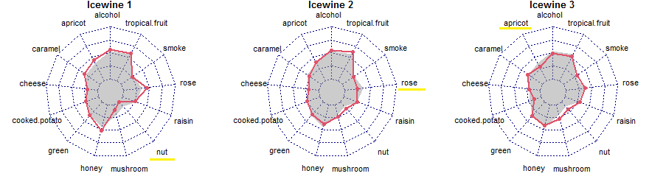
Supplementary Figure 1 The odor profile of icewine. The red line represents the odor profile based on the sample’s MI values, and the gray shading represents the odor profile of icewine based on the average MI value calculated across three sessions. The significance of differences between odor attributes were tested with paired two-sided Wilcoxon tests and are marked by underlines in different colors (yellow: p<0.05; light orange: p<0.01; dark orange: p<0.001).

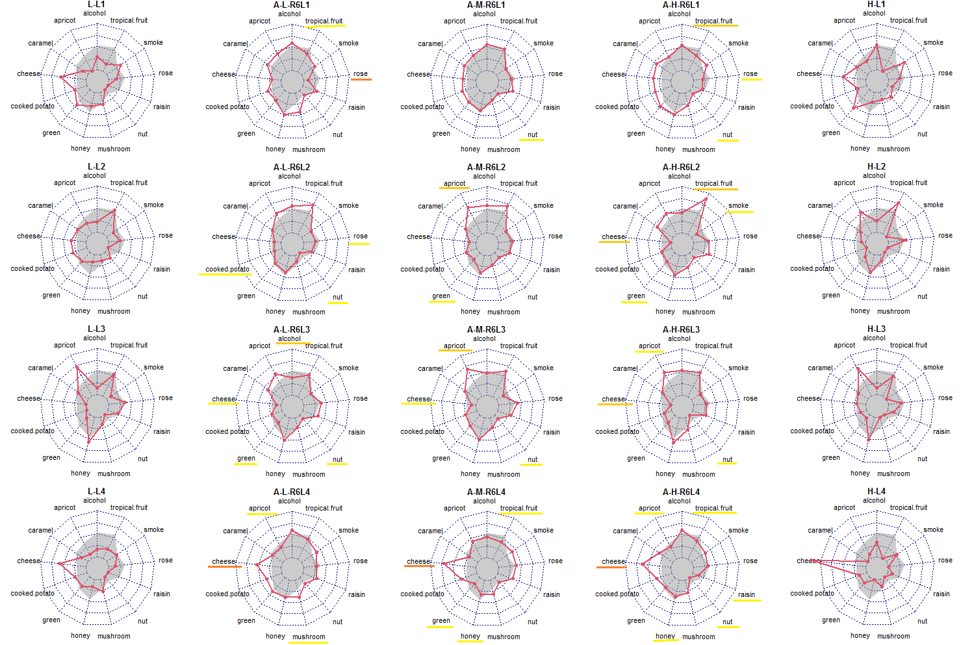
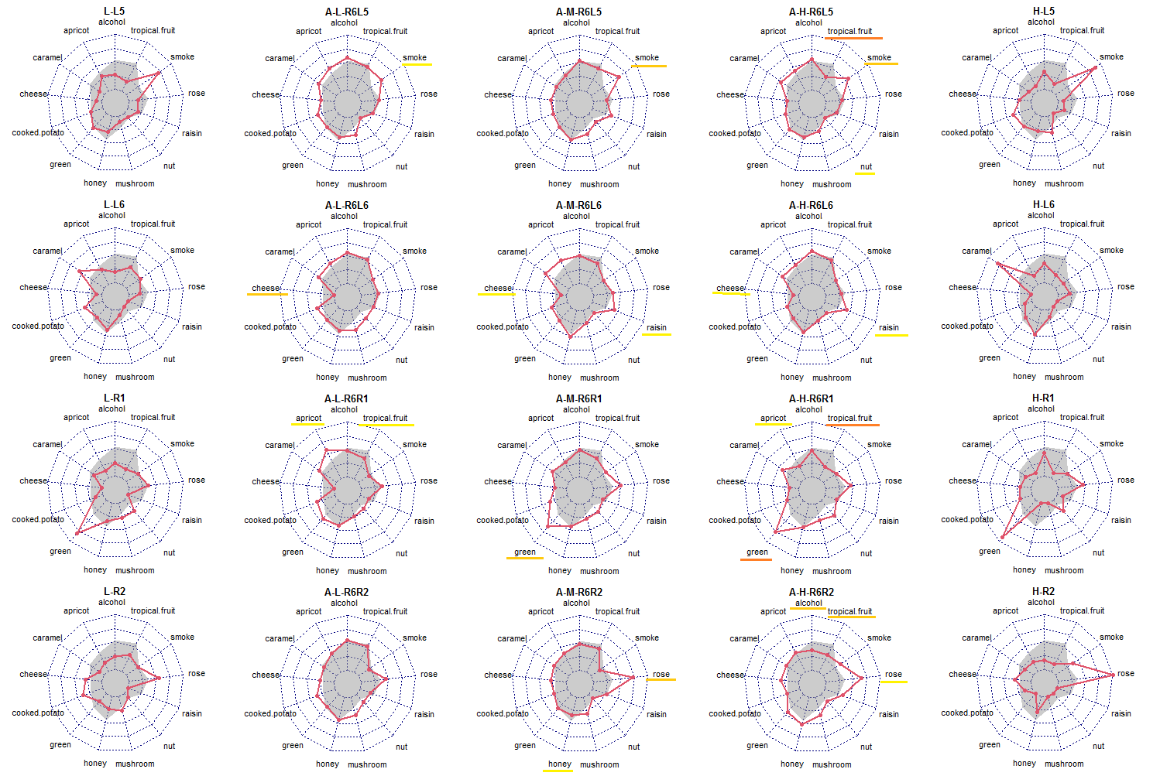
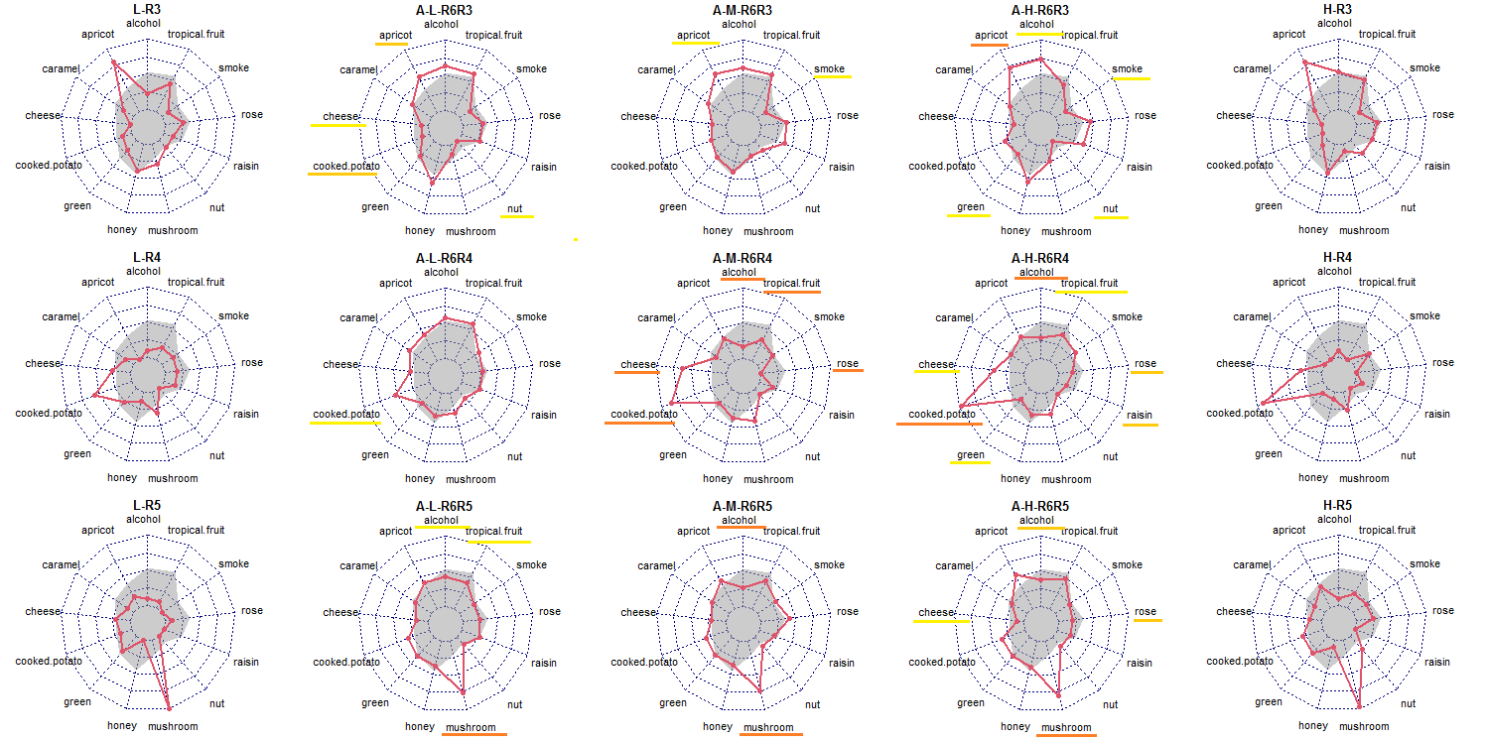
Supplementary Figure 2 The odor profile of the 11 key odorants and the odor profile of the 11 key odorants within icewine odor buffer. The red line represents the odor profile based on the sample’s MI values, and the gray shading represents the odor profile of icewine of icewine based on the average MI value calculated across three sessions. The significance of differences between odor attributes were tested with paired two-sided Wilcoxon tests and are marked by underlines in different colors (yellow: p<0.05; light orange: p<0.01; dark orange: p<0.001). The code of the sample is indicated at the top of each small picture, where the code L-R5 represents the low-intensity level for odorant R5 (1-octen-3-one, see in Supplementary Table 1); the code H-R5 represents the high-intensity level for odorant R5; Code A-L-R6R5 represents the sample generated by adding odorant R5 (1-octen-3-one) at low intensity to the icewine odor (R6); code A-M-R6R5 represents the sample generated by adding odorant R5 (1-octen-3-one) at medium intensity to the icewine odor (R6); code A-H-R6R5 represents the sample generated by adding odorant R5 (1-octen-3-one) at high intensity to the icewine odor (R6).
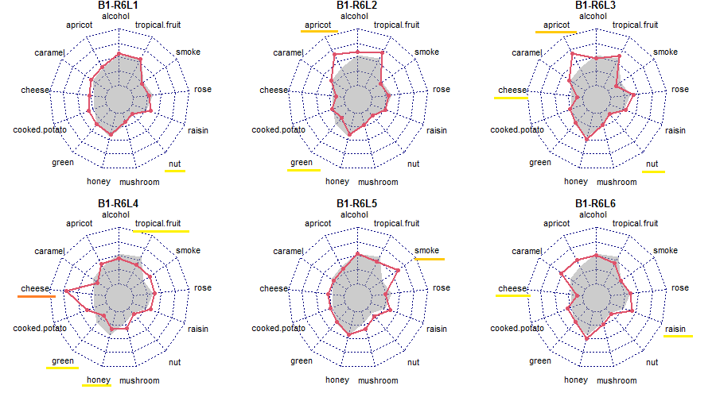
Supplementary Figure 3 The odor profile of odor mixtures of the 6 key individual odorants combined with the icewine odor. The red line represents the odor profile based on the sample’s MI values, and the gray shading represents the odor profile of icewine based on the average MI value calculated across three sessions. The significance of differences between odor attributes were tested with paired two-sided Wilcoxon tests and are marked by underlines in different colors (yellow: p<0.05; light orange: p<0.01; dark orange: p<0.001). The code of the sample is indicated at the top of each small picture. Code code B1-R6L5 represents the sample generated by adding odorant L5 (guaiacol) at medium intensity to the icewine odor (R6).

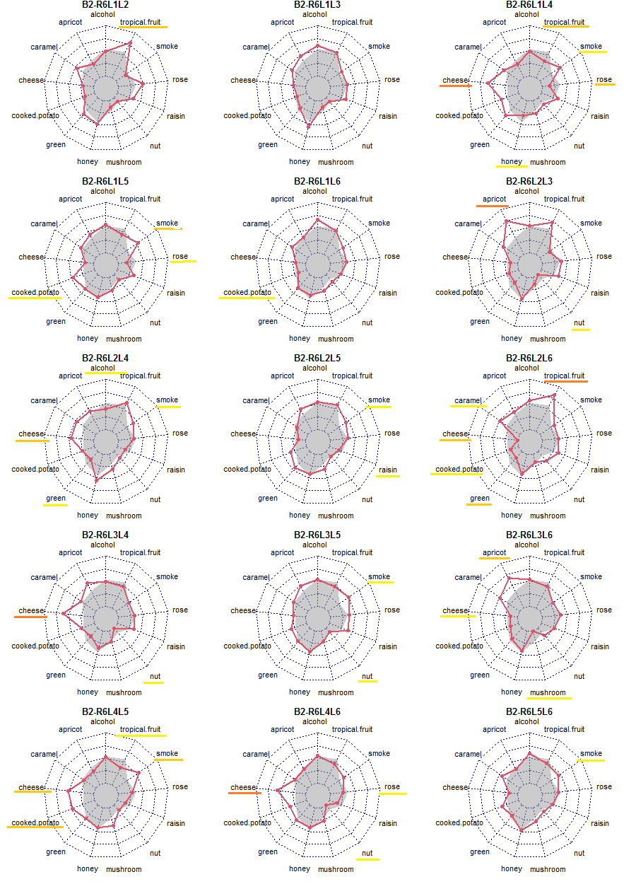
Supplementary Figure 4 The odor profile of odor mixtures of two-odorants combined with the icewine odor. The odor profile of odor mixtures of the 6 key individual odorants combined with the icewine odor. The odor profile of two- odorant combinations made from the 6 key odorants and added to the icewine odor. The red line represents the odor profile based on the sample’s MI values, and the gray shading represents the odor profile of icewine based on the average MI value calculated across three sessions. The significance of differences between odor attributes were tested with paired two-sided Wilcoxon tests and are marked by underlines in different colors (yellow: p<0.05; light orange: p<0.01; dark orange: p<0.001). The code of the sample is indicated at the top of each small picture, where the code B2-R6L5L6 represents the sample generated by adding odorant L5 (guaiacol) and odorant L6 (furaneol) at medium intensity to the icewine odor (R6).

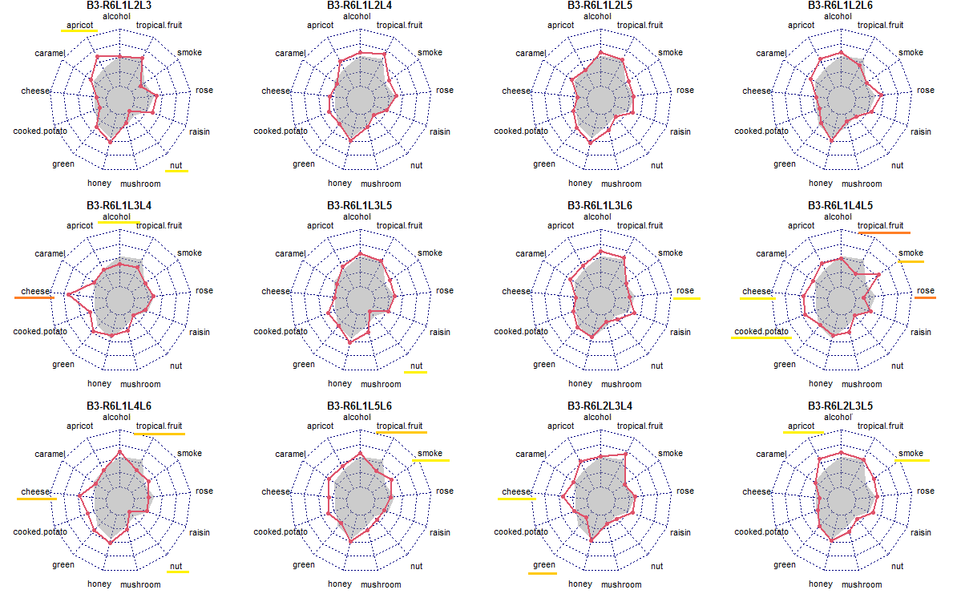
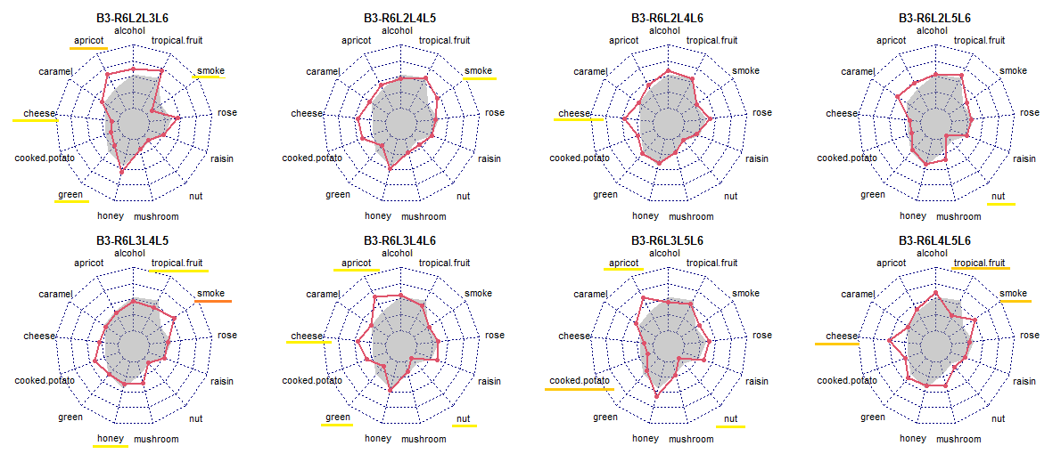
Supplementary Figure 5 The odor profile of odor mixtures of three-odorants combined with the icewine odor. The red line represents the odor profile based on the sample’s MI values, and the gray shading represents the odor profile of icewine based on the average MI value calculated across three sessions. The significance of differences between odor attributes were tested with paired two-sided Wilcoxon tests and are marked by underlines in different colors (yellow: p<0.05; light orange: p<0.01; dark orange: p<0.001). The code of the sample is indicated at the top of each small picture, where the code B3-R6L4L5L6 represents the sample generated by adding odorant L4 (3-methylbutanoic acid), odorant L5 (guaiacol) and odorant L6 (furaneol) at medium intensity to the icewine odor (R6).

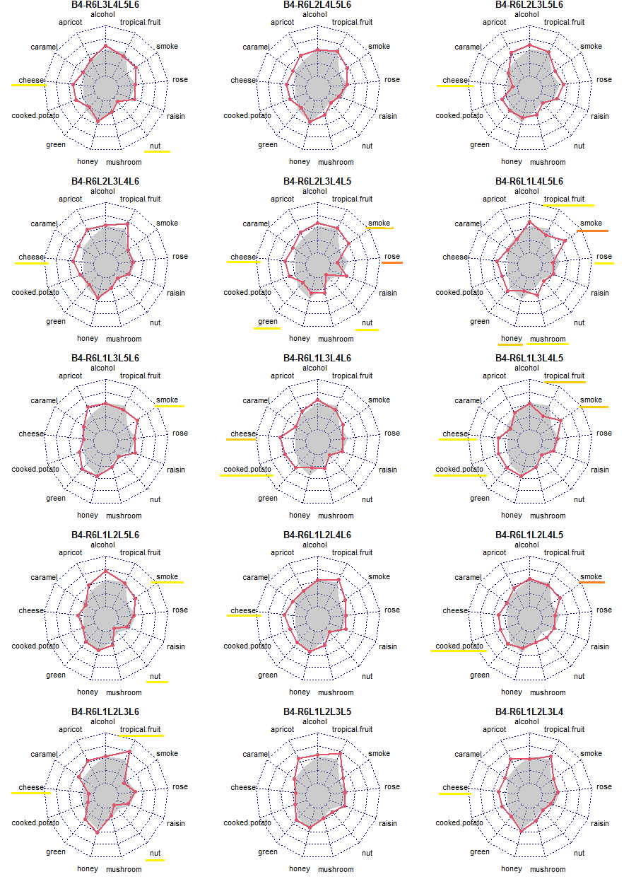
Supplementary Figure 6 The odor profile of odor mixtures of four-odorants combined with the icewine odor. The red line represents the odor profile based on the sample’s MI values, and the gray shading represents the odor profile of icewine based on the average MI value calculated across three sessions. The significance of differences between odor attributes were tested with paired two-sided Wilcoxon tests and are marked by underlines in different colors (yellow: p<0.05; light orange: p<0.01; dark orange: p<0.001). The code of the sample is indicated at the top of each small picture, where the code B4-R6L3L4L5L6 represents the sample generated by adding odorant L3 (β-damascenone), odorant L4 (3-methylbutanoic acid), odorant L5 (guaiacol) and odorant L6 (furaneol) at medium intensity to the icewine odor (R6).

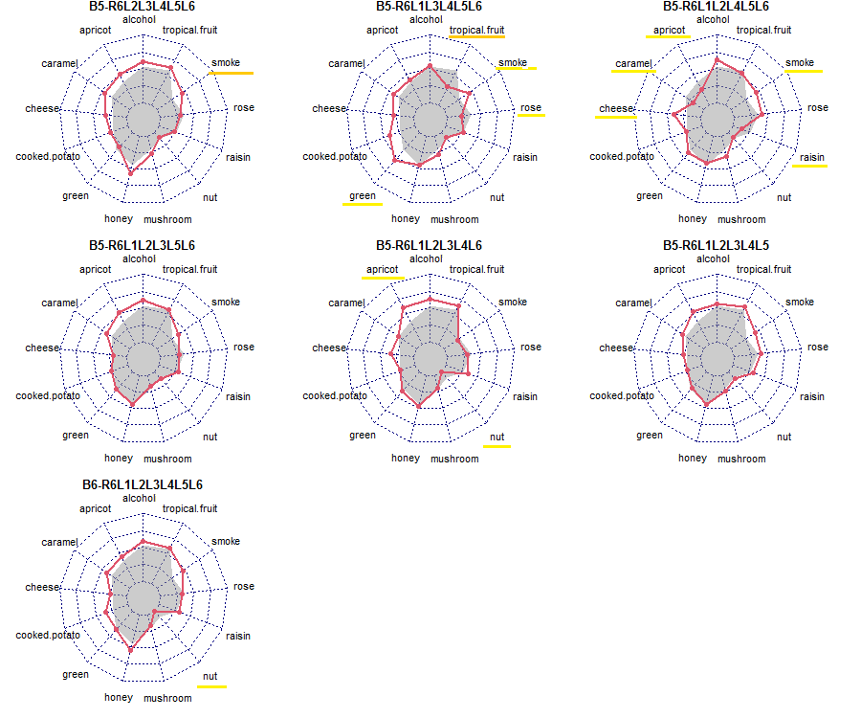
Supplementary Figure 7 The odor profile of odor mixtures of five-odorants and six-odorants combined with the icewine odor. The red line represents the odor profile based on the sample’s MI values, and the gray shading represents the odor profile of icewine based on the average MI value calculated across three sessions. The significance of differences between odor attributes were tested with paired two-sided Wilcoxon tests and are marked by underlines in different colors (yellow: p<0.05; light orange: p<0.01; dark orange: p<0.001). The code of the sample is indicated at the top of each small picture, where the code B6-R6L1L2L3L4L5L6 represents the sample generated by adding odorant L1 (3-methyl-1-butanol), odorant L2 (ethyl 2-methyl butanoate), odorant L3 (β-damascenone), odorant L4 (3-methylbutanoic acid), odorant L5 (guaiacol) and odorant L6 (furaneol) at medium intensity to the icewine odor (R6).

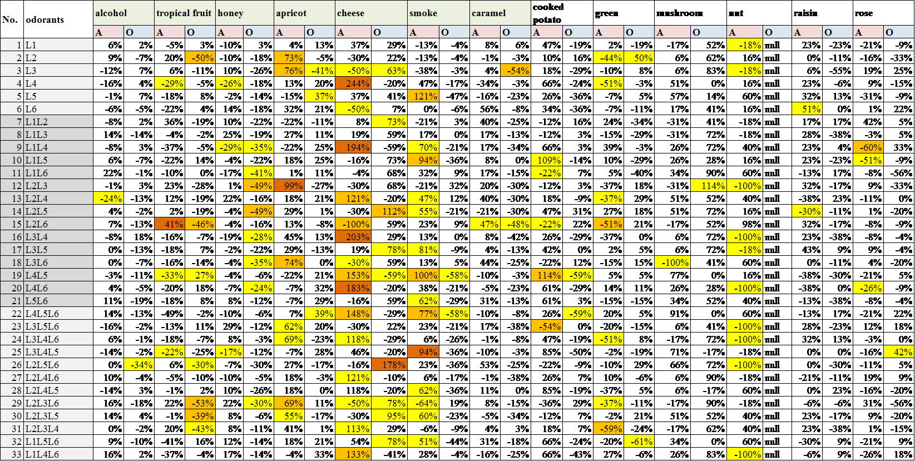
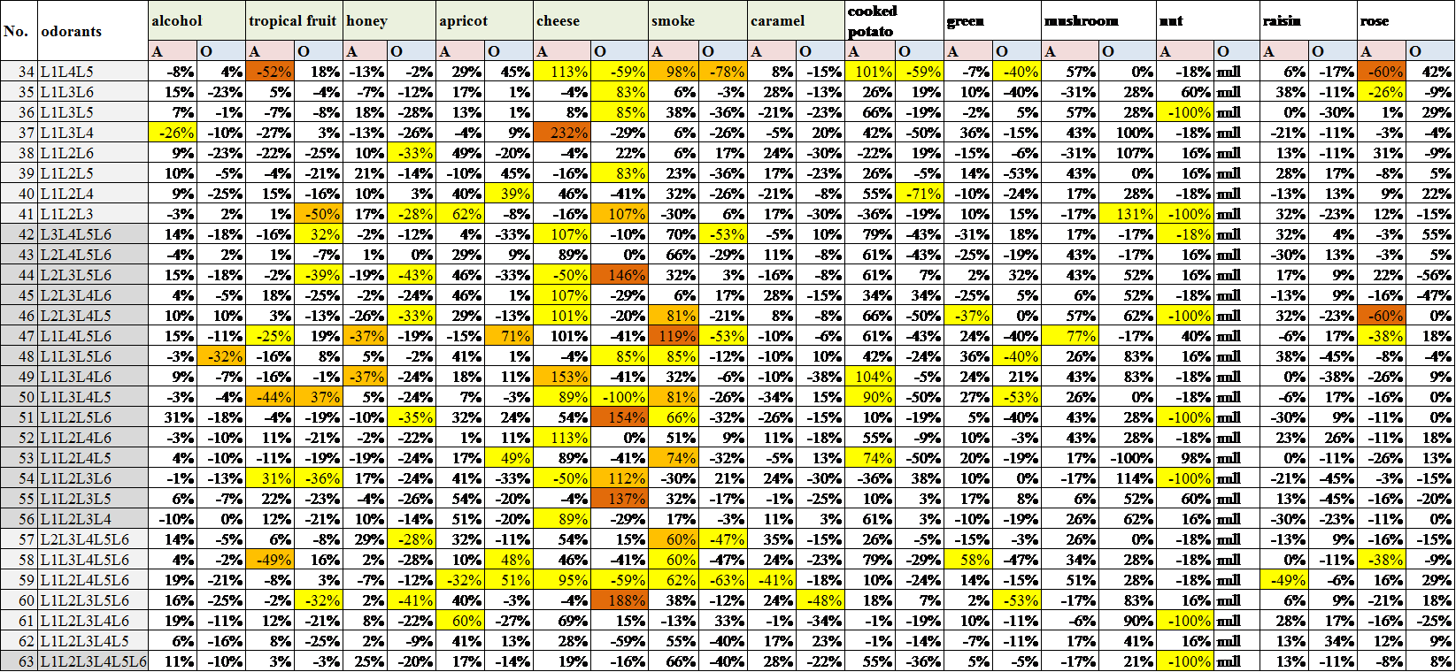
Supplementary Figure 8 Analysis of the changes in odor attributes of samples with different odorant combinations and the significance of the differences. The column ‘odorants’ represents the odorants manipulated (added or omitted) in the sample. The descriptors marked by green cells were the target descriptors related to the different odorants (i.e. L1, alcoholic; L2, tropical fruit; L3, honey/ apricot; L4, cheese; L5, smoky; and L6, caramel). The column ‘A’ represents the percent change between the sample and the icewine odor reference sample; The column ‘O’ represents the percent change between the sample and the sample made of the icewine odor in which the 6 odorants were added (B6-R6L1L2L3L4L5L6). For example, for the sample L1L2L3L4L5L6, the value in column ‘A’ was calculated as following (MI_{B6-R6L1L2L3L4L5L6}-MI_{icewine})/ MI_{icewine}; the value in column ‘O’ was calculated as following (MI_{icewine}-MI_{B6-R6L1L2L3L4L5L6})/ MI_{B6-R6L1L2L3L4L5L6。}The significance of the difference between attributes was test by using a paired two-sided Wilcox test and is identified in each cell with different colors (yellow: p<0.05; light orange: p<0.01; dark orange: p<0.001); in column ‘A’, the difference was compared between MI_{sample}~ MI_{icewine} and in column ‘O’, the difference was compared between MI_{sample}~ MI_{B6-R6L1L2L3L4L5L6}

